UNITED STATES
SECURITIES AND EXCHANGE COMMISSION
WASHINGTON, D.C. 20549

SCHEDULE 14A

Proxy Statement Pursuant to Section 14(a) of the
Securities Exchange Act of 1934 (Amendment No. )

Filed by the Registrant ☒

Filed by a Party other than the Registrant ☐

Check the appropriate box:

☐ Preliminary Proxy Statement

☐ Confidential, For Use of the Commission Only (as permitted by Rule 14a-6(e)(2))

☐ Definitive Proxy Statement

☒ Definitive Additional Materials

☐ Soliciting Material Under Rule 14a-12

Carriage Services, Inc.
(Name of Registrant as Specified In Its Charter)

(Name of Person(s) Filing Proxy Statement, if other than the Registrant)

Payment of Filing Fee (Check the appropriate box):

☒ No fee required.

☐ Fee paid previously with preliminary materials.

☐ Fee computed on table below per Exchange Act Rules 14a-6(i)(1) and 0-11.

 | 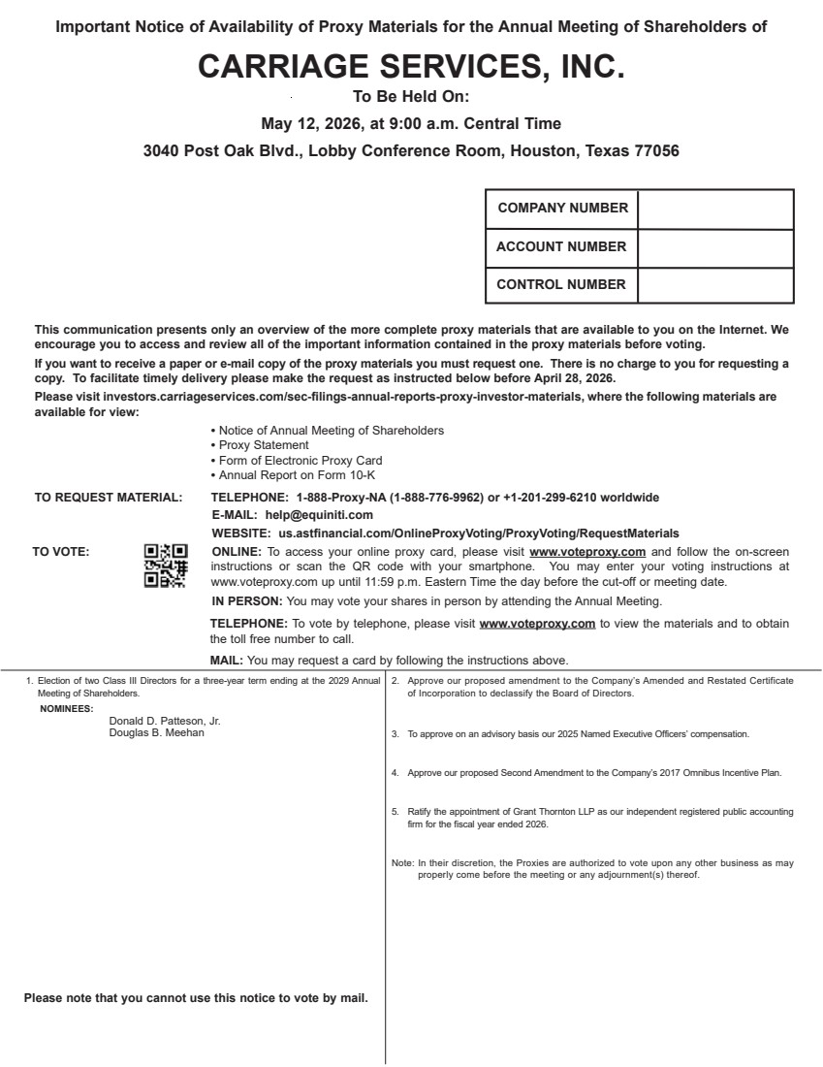 | 1. Election of two Class III Directors for a three-year term ending at the 2029 Annual Meeting of Shareholders. Donald D. Patteson, Jr. Douglas B. Meehan 2. Approve our proposed amendment to the Company’s Amended and Restated Certificate of Incorporation to declassify the Board of Directors. 3. To approve on an advisory basis our 2025 Named Executive Officers’ compensation. 4. Approve our proposed Second Amendment to the Company’s 2017 Omnibus Incentive Plan. 5. Ratify the appointment of Grant Thornton LLP as our independent registered public accounting firm for the fiscal year ended 2026. Note: In their discretion, the Proxies are authorized to vote upon any other business as may properly come before the meeting or any adjournment(s) thereof. NOMINEES: This communication presents only an overview of the more complete proxy materials that are available to you on the Internet. We encourage you to access and review all of the important information contained in the proxy materials before voting. If you want to receive a paper or e-mail copy of the proxy materials you must request one. There is no charge to you for requesting a copy. To facilitate timely delivery please make the request as instructed below before April 28, 2026. Please visit investors.carriageservices.com/sec-filings-annual-reports-proxy-investor-materials, where the following materials are available for view: • Notice of Annual Meeting of Shareholders • Proxy Statement • Form of Electronic Proxy Card • Annual Report on Form 10-K TO REQUEST MATERIAL: TELEPHONE: 1-888-Proxy-NA (1-888-776-9962) or +1-201-299-6210 worldwide E-MAIL: help@equiniti.com WEBSITE: us.astfinancial.com/OnlineProxyVoting/ProxyVoting/RequestMaterials TO VOTE: ONLINE: To access your online proxy card, please visit www.voteproxy.com and follow the on-screen instructions or scan the QR code with your smartphone. You may enter your voting instructions at www.voteproxy.com up until 11:59 p.m. Eastern Time the day before the cut-off or meeting date. IN PERSON: You may vote your shares in person by attending the Annual Meeting. TELEPHONE: To vote by telephone, please visit www.voteproxy.com to view the materials and to obtain the toll free number to call. MAIL: You may request a card by following the instructions above. COMPANY NUMBER ACCOUNT NUMBER CONTROL NUMBER JOHN SMITH 1234 MAIN STREET APT. 203 NEW YORK, NY 10038 Please note that you cannot use this notice to vote by mail. Important Notice of Availability of Proxy Materials for the Annual Meeting of Shareholders of CARRIAGE SERVICES, INC. To Be Held On: May 12, 2026, at 9:00 a.m. Central Time 3040 Post Oak Blvd., Lobby Conference Room, Houston, Texas 77056
 | 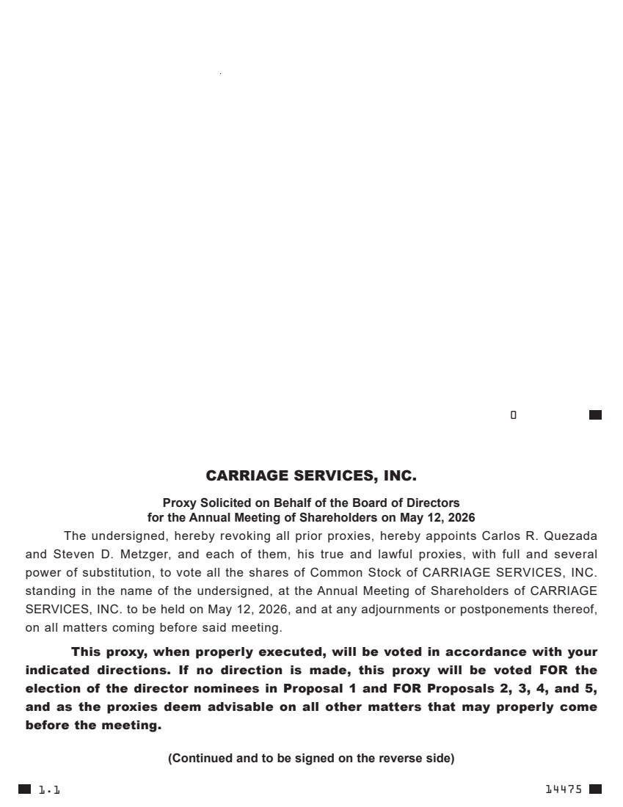 | 0 ------------------ . . . . . . . . . . . . . . . . . . . . . . . . . . . . . . . . . . . . . . . . . . . . . . . . . . . . . . ---------------- 14475 CARRIAGE SERVICES, INC. Proxy Solicited on Behalf of the Board of Directors for the Annual Meeting of Shareholders on May 12, 2026 The undersigned, hereby revoking all prior proxies, hereby appoints Carlos R. Quezada and Steven D. Metzger, and each of them, his true and lawful proxies, with full and several power of substitution, to vote all the shares of Common Stock of CARRIAGE SERVICES, INC. standing in the name of the undersigned, at the Annual Meeting of Shareholders of CARRIAGE SERVICES, INC. to be held on May 12, 2026, and at any adjournments or postponements thereof, on all matters coming before said meeting. This proxy, when properly executed, will be voted in accordance with your indicated directions. If no direction is made, this proxy will be voted FOR the election of the director nominees in Proposal 1 and FOR Proposals 2, 3, 4, and 5, and as the proxies deem advisable on all other matters that may properly come before the meeting. (Continued and to be signed on the reverse side) 1.1

